**DFD FOR ONLINE MUSICAL INSTRUMENT RENTAL SHOP MANAGEMENT SYSTEM**

# LEVEL 0 DFD SHOWING ONLINE MUSICAL INSTRUMENT RENTAL SHOP MANAGEMENT SYSTEM

Request

Musical Instruments Rental Shop Management System

Response

User

# LEVEL 1 DFD SHOWING ONLINE MUSICAL INSTRUMENT RENTAL SHOP MANAGEMENT SYSTEM

staff details

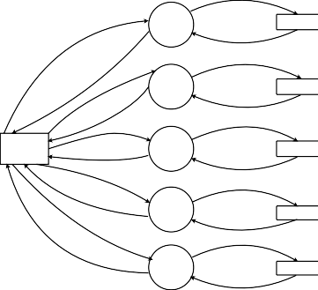

1.0

Staff Management

tbl_staff

successfully stored

customer details

2.0

Customer Management

tbl_customer

successfully stored

Product details

Product details

User

successfully stored

3.0

Product Management

tbl_itemmaster

successfully stored

order details

5.0

Order Management

tbl_Ordermaster

successfully stored

payment details

6.0

Payment Management

tbl_Payment

successfully stored

# LEVEL 2 DFD SHOWING STAFF MANAGEMENT

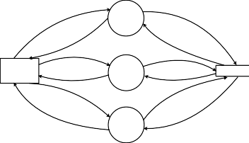

1.1

Add Staff

staff id

staff id

User

1.2

Edit Staff

tbl_staff

successfully stored

successfully stored

1.3

Search Staff

**LEVEL 2 DFD SHOWING CUSTOMER MANAGEMENT**

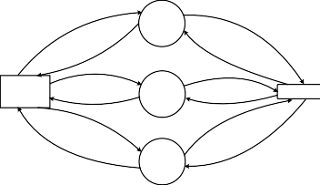

2.1

Register Customer

register id,details

register id,details

User

2.2

Edit Customer

tbl_register

successfully updated

successfully updated

2.3

Search Customer

**LEVEL 2 DFD SHOWING PRODUCT MANAGEMENT**

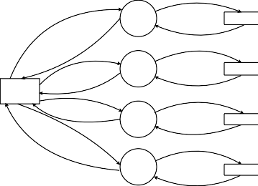

category details

3.1

Caregory Management

tbl_category

successfully stored

variety details

variety details

3.2

Variety Management

tbl_variety

successfully stored

User

brand details

successfully stored

3.3

Brand Management

tbl_brand

successfully stored

item details

3.4

Item Management

tbl_itemmaster

successfully stored

**LEVEL 2 DFD SHOWING ORDER MANAGEMENT**

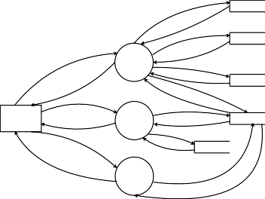

tbl_register

tbl_itemchild

5.1

Add Order

tbl_ordermaster

order child id,details

User

successfully updated

5.2

Edit Order

successfully updated

tbl_orderchild

tbl_itemchild

5.3

Search Order

order child id

**LEVEL 2 DFD SHOWING PAYMENT MANAGEMENT**



tbl_register

6.1

Add Payment

tbl_ordermaster

tbl_payment

6.2

View Payment

User

**LEVEL 3 DFD SHOWING CATEGORY MANAGEMENT**

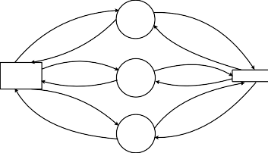

3.1.1

Add Category

category id,details

category id,details

User

3.1.2

Update Category

tbl_category

successfully updated

successfully updated

3.1.3

Search Category

**LEVEL 3 DFD SHOWING VARIETY MANAGEMENT**

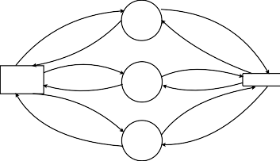

3.2.1

Add Variety

variety id,details

variety id,details

User

3.2.2

Update Variety

tbl_variety

successfully updated

successfully updated

3.2.3

Search Variety

**LEVEL 3 DFD SHOWING BRAND MANAGEMENT**

**LEVEL 3 DFD SHOWING ITEM MANAGEMENT**

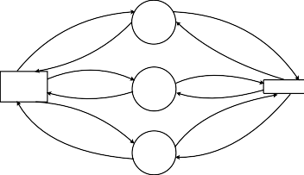

3.3.1

Add Brand

brand id,details

brand id,details

User

3.3.2

Edit Brand

tbl_brand

successfully updated

successfully updated

3.3.3

Search Brand

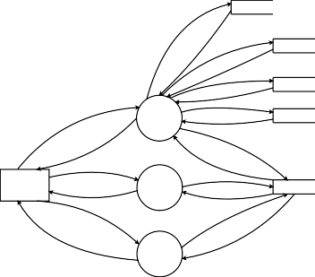

tbl_category

tbl_variety

request brand id

tbl_brand

item details

3.4.1

Add Item

successfully stored

tbl_itemmaster

item id,details

item id,details

User

successfully updated

3.4.2

Edit Item

tbl_itemchild

3.4.3

Search Item